
October 2026 No.466
THE LINK

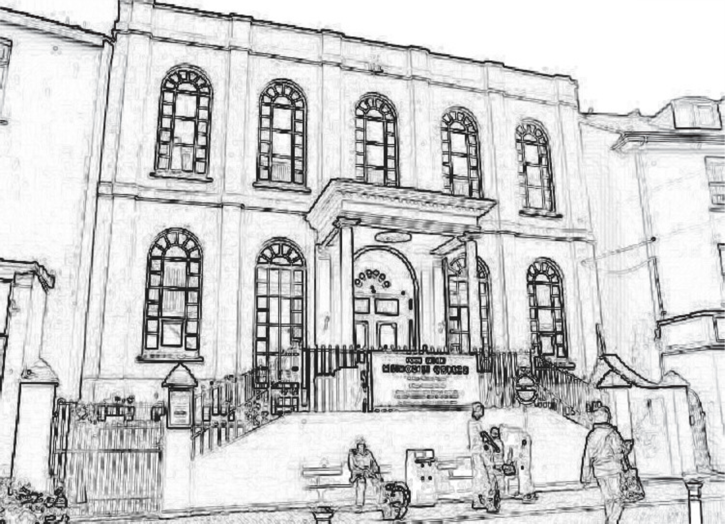

What’s in this month’s Link?
Message from the Minister | 1
A Prayer for Brixham | 1
Church Family News | 2
Church Diary | 3
The Lectionary - October | 4


It seems a very short time since we were moving out have a very hot Summer and yet already there's a temptation to put on the heating! Autumn is well and truly here and with it the signs of a new season are all around us. We’re looking forward to our Harvest celebrations of land and sea on the 4th October when Helen Lovell from the Mission will be with us to share in the service. We will of course have already enjoyed a pasty supper on the 3rd October at 6:30pm. Tickets on sale from the stewards.
Our thoughts and prayers have been with Sue Hamling over the past few weeks as her sister has been so poorly and has since died. We continue to think about Sue and her family at this sad time.
It's always good when we have news of our dear friend, Gordon Chambers. He continues in Bristol at the moment and would love to hear from his Torbay Circuit friends. Permission has been given for his address to be printed so please be in touch if you can. He also has his 90th birthday on November 21st (just thought we'd mentioned that!!) Gordon lived at Horfield Lodge Care Home, Kellaway Avenue, Bristol BS7 8SU.
We are all delighted that our Senior Steward, Marilyn is making really good progress following her second hip operation. We thank God that the operation has happened at last and we all pray for her continued recovery.
Frank Vond has been in hospital but his home safely now we think about Frank and all the family and pray that he will soon be fit and well again. Wi-Fi is (almost) up and running in the Christian Community Centre! We’ve nearly made it into the 21st century! Putting this in has proved very tricky and our thanks must go to the members of the Property Committee and David Taylor for all their hard work and tenacity!!
During this season may we all remember each other in prayer with gratitude thanking God for the love and care he showered upon us each and every day.
2

Message from the Minister
For grace is not given to us because we have done good works, but in order that we may be able to do them.' - Augustine.
The quote from Augustine came up as my 'thought for the day as I prepared to write this next piece for early in Methodist New Year. It is so much like, 'We love because he first loved us' (1John 4:19). God starts love: God loved us first, we do not have to make God love us. The thought is really about how we ought to respond; we can love God and other people because God showed what love is first. Love is not something people make up on their own; it comes from God.
What might a grace and love response look like? Well, and not meaning to big myself up, I have been deeply touched by the move of the new Prime Minister to get Everybody In for Christmas. It is my intention to sleep in a tent in my garden for November, with sponsorship. Of course, sleeping in a tent is not a life on the streets. Monies raised would go to Shelter or the like. To suggest sleeping for a month in a tent says that means I know what it is to be homeless would be like wearing a blindfold and saying I know what it is to be blind, or putting ear plugs in and saying that means I understand what iit is to be hard of hearing. However, doing something as little as this iis to stand (nay, sleep) in solidarity with those very much on the margins.
Praying it is not too cold.
Andy

A Prayer for Brixham
Dear Lord. We thank you that we can bring our requests to you. This month we ask for your blessing on those who provide transport services in and through Brixham - buses, trains, taxis and the many people who give lifts to members of our community, often without payment. We thank you for all these services.
In Jesus name we pray.
Amen
contributed by May

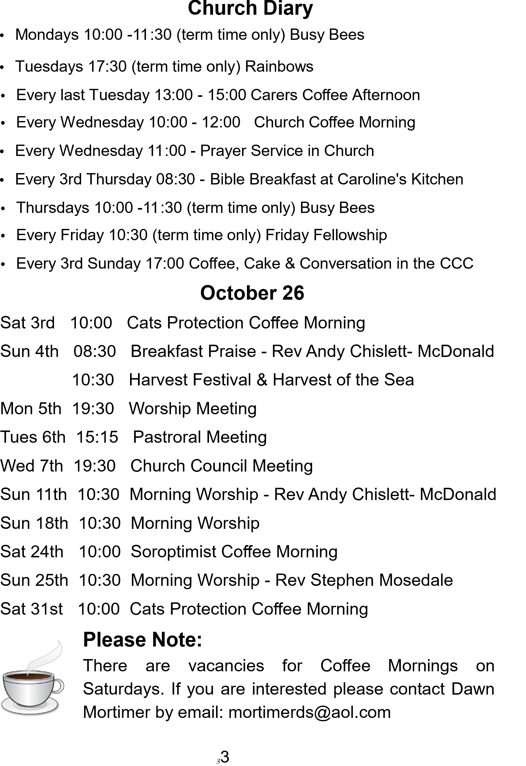
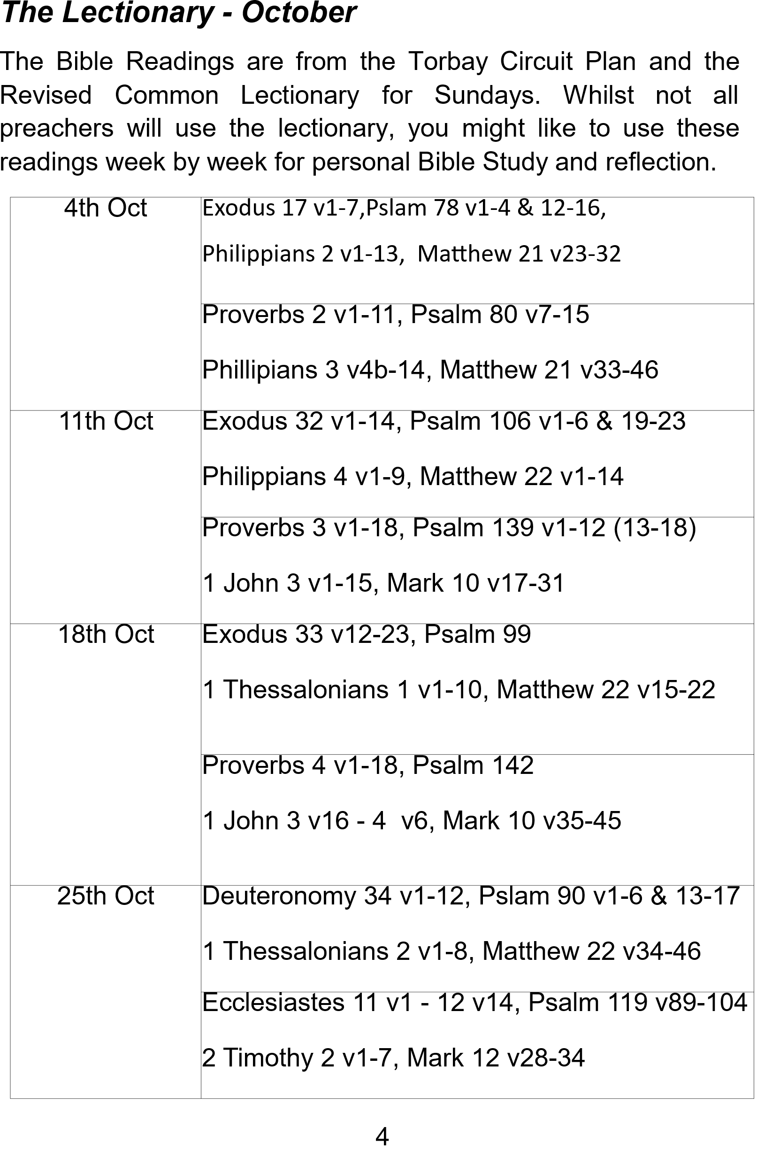


PLEASE REMEMBER
The submission date for the October edition of the Link is 11th September.
Articles can be:
• put in the red box in the Church entrance
• sent by post to 17 North Boundary Road, Brixham, TQ5 8LH
• sent by email to 54aklucas@gmail.com
It would be useful if you could provide a contact telephone number or email address in case I have any queries.
All articles submitted by email will be acknowledged asap. If you do not get a response, please contact me so that I can rectify any problems.
Many thanks
Angela Lucas

It costs 50p to produce this magazine but it is FREE to you.
If, however you wish to contribute to its production it would be very much appreciated.

